Criando o Service productSrv.js

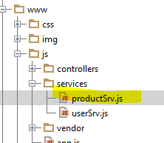

**angular**.module(**'starter.services'**).**factory**(**'Product'**, [**'$resource'**, **'appDevConfig'**, **function** ($resource, appDevConfig) {  
 **return** $resource(appDevConfig.**baseUrl** + **'api/client/products'**, {}, {  
 **query**: {  
 **isArray**: **false** }  
 });  
}]);

Chamando no Controller viewProductCtrl.js

**angular**.module(**'starter.controllers'**).**controller**(**'ClientViewProductCtrl'**,[  
 **'$scope'**, **'$state'**, **'Product'**, **function** ($scope, $state, Product) {  
  
 $scope.**products** = Product.query({}, **function**(data) {  
 ***console***.log(data);  
 });  
  
 }]);